**Brooklyn torah gazette**

**For parshas emor 5782**

Volume 6, Issue 33 (Whole Number 288) 13 Iyar/ May 14, 2022

**American Jewish Chaplains and the Displaced Jews of WWII**

**By**[**Alex Grobman PhD.**](https://www.jewishpress.com/author/alexgrobman/)

 -

[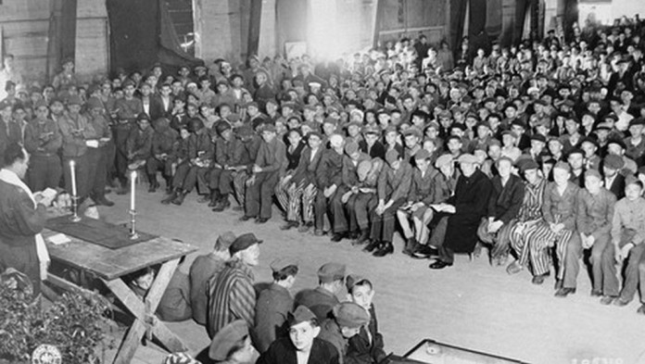](https://www.jewishpress.com/wp-content/uploads/Rabbi-Herschel-Schachter-conducts-services-for-Holocaust-survivors-on-the-Jewish-festival-of-Shavuot-in-the-Buchenwald-concentration-camp-May-16-1945.-Wikimedia-Commons.jpg)**Rabbi Herschel Schachter conducts services for Holocaust survivors on the Jewish festival of Shavuot, in the Buchenwald concentration camp, May 16, 1945.**

At Yom HaShoah memorials, American soldiers who participated in the liberation of a concentration or slave labor camp have often been recognized and applauded for their efforts. Often these soldiers had little opportunity of offering Jewish survivors more than limited assistance since they were in mobile units involved in completing a military campaign.

The unforeseen task of aiding the Jewish Displaced Persons (DPs) became the concern of American Jewish chaplains who passed through Germany, Austria, and Italy during the initial occupation period April-June 1945. The chaplains were among the first American Jews to encounter survivors.

Although the chaplain’s primary duty was to administer to the spiritual and psychological needs of the American soldiers,  a number elected to aid the Jewish DPs. It is important to appreciate the chaplains did not officially represent the American rabbinate or any other American Jewish organization in their work with the DPs. Of the 311 Reform, Conservative and Orthodox Jewish chaplains, more than 90 had direct interaction with them from 1944-1948.

The chaplain’s involvement was especially critical because the  American military government failed to appreciate the Jews had special needs having been selected for total annihilation.

The obvious solution the Army believed, was for the DPs to return to their former homes—regardless of the situation in their countries of origin. For a significant number of them, this was no longer a realistic option. Most non-Jewish DPs, on the other hand, were eager to return to their homelands.

Even after being liberated, the Jews were forced to live with inadequate food, clothing, medical care, and the inability to decide their own destiny.

As one historian noted, the DP Branch of the Supreme Headquarters Allied Expeditionary Force (SHAEF) had no idea “how to deal with the wreckage of human minds and spirits, which was to constitute their major problem in Germany.”

**Cologne Region**

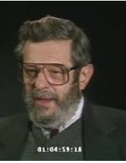

**Eugene Jay Lipman (1919-1994)**

Among the most effective chaplains was Eugene Lipman, a Reform rabbi in his mid-20s, assigned to Headquarters XII Corps. When he entered the army in August 1944, there had never been any discussion in his interviews with the Jewish Welfare Board, which served as the sole endorsing body for Jewish chaplains in the military, in the Chaplains’ School

or before he and his fellow chaplains left for Europe about meeting Jewish survivors. Lipman observed “It hadn’t occurred to any of us as an active possibility that we might have to face Jewish survivors.”

In the Cologne region, he found DPs who desperately required his help: 200 Jews from Buchenwald, Dachau, and Theresienstadt. To aid them, Lipman asked many Jewish soldiers scattered through the Ruhr (the region from below Cologne to Essen and Duisburg) to beg, borrow, or steal food packages from their mess units. In addition, together with a few Jewish soldiers, he would go out at night to army food dumps and steal huge amounts of rations. This project lasted only about a month, for on June 15, 1945, he was transferred to Pilsen, Czechoslovakia.

When Lipman arrived in Pilsen, he was recruited to work with the *Brichah*, the underground mass migration of Jews from Eastern Europe (between 1944 and 1948) to Palestine. There were 6,000 Jews starving in Prague and another 16,000 still in Theresienstadt in the Russian zone of occupation, which they tightly controlled. Lipman was asked to provide material and logistical aid to the Jews so they could be transported from Prague to Pilsen, and from there to Salzburg, Austria. Once in Austria, they would be taken to Italy and then to Palestine. Transferring the Jews across the Danube to Salzburg had to be accomplished without being arrested by troop patrols, military police or counterintelligence agents.

Lipman appropriated trucks and gas from the Third Army, and when a shortage of fuel developed, they had to purchase gasoline on the black market.

**Northern Bavaria**

In Northern Bavaria, Lipman found groups of Jews throughout Niederbayern  and Oberplaz, who were in need of clothing and a means to contact their relatives. He helped them establish *hachsharot*  (pioneer training collectives) to prepare them for life in *Eretz Israel.* Lipman and his assistant Simon Pava, visited the different DP camps and communities in the area to help with legal, medical and social issues, and provided relief and assisted with children’s groups. The extent of the work became too time-consuming, even after a Central Committee for Northern Bavaria was established. Fortunately. Joseph Levine, the first JDC worker to arrive in the region, slowly began assuming their responsibilities.

**Package and Mail Enterprise**

While in Northern Bavaria, Lipman initiated a package and mail campaign. Between October 1945 and May 1946, he received between 175-180 tons of packages, which were housed in a warehouse he requisitioned near the Jewish community house. This afforded pregnant women, children , nursing mother and the elderly with food they desperately needed.

The postal system he created also became a substantial operation. At one point, 2,000-2,500 letters were sent from Germany, and 500-600 were received every week. Because the DPs were not permitted to send mail on their own, each letter had to be readdressed with Lipman’s military address and military rank. When the amount of outgoing mail became too overwhelming, he enlisted the help of Jewish organizations in the US, Canada and England. The incoming letters presented another challenge. Many did not have an address or any identification. These letters had to be returned with instructions to address the outer envelope to Lippman and the inner one to the DP.

Because the package and mail projects were not sanctioned by the army, the chaplains risked reprimand. In late 1945, mail sent to England burst open, tossing the letters throughout the aircraft. The European Theater postal officer immediately called for an investigation with Lipman being summoned before the chief of staff of his division. After being told that DPs were forbidden to use the mails, Lipman explained they could not wait six to twelve months for the military to correct this problem. The officer apparently agreed. With a broad grin he told Lipman: Consider yourself reprimanded and get the hell out of here.”

When Lipman was assigned to the Wetzlar Military Post he and other chaplains were involved in getting Jews out of Germany and Austria, by supplying trucks, food, gasoline and clothing and false papers.

**A Final Note**

In discussing the *mesirat nefesh* (self-sacrifice) of the chaplains, Rabbi Philip Bernstein, who served as executive director of the Commission on Army and Navy Religious Activities, declared “ No written testimony can possibly do justice to their devotion, their sacrifices , and their accomplishments.” At a time when the survivors urgently required their help, chaplains like Rabbi Eugene Lipman showed, in word and deed, they were no longer alone.

Dr. Alex Grobman is the senior resident scholar at the John C. Danforth Society and a member of the Council of Scholars for Peace in the Middle East.

*Reprinted from the April 28, 2022 email of Arutz Sheva (Israel News)*

**Rav Avigdor Miller on The**

**Coatroom and Olam Haboh**



**QUESTION: You told us before a story about a Jewish woman in the Middle Ages who was dragged to her death by anti-semites who tied her to the back of a horse. Why does Hashem test His children so severely to the point of having a good woman killed like that?**

**ANSWER:** And the answer, my friend, is as follows. You know, when you go to a wedding, you walk into the lobby and there is a room where somebody is taking your coat and in return for your expensive coat he gives you a little slip of paper. And it seems as silly as could be. If you’re a child and you walk in and see such a thing, you think people are crazy. They’re trading in their good coats and they’re getting a little piece of paper. He wouldn’t do such a foolish thing!

It’s only when you know what’s the story behind that, that there’s a big hall inside and a banquet where you sit and you rejoice and have a good time and after the banquet is over then you go back and you get your coat back, then it starts to make sense.

When a man doesn’t know about the World to Come and he sees that we have to deposit our bodies he gets flustered. And sometimes the clerk who is behind the counter gives you not only a ticket, but with the ticket he gives you a punch. It happens.

Like Hitler. Hitler was a very important cloakroom attendant. He led millions of Jews out of this world. They gave him their bodies. And if you’re ignorant of the World to Come so it doesn’t make any sense at all to give away your bodies.

But we have to realize that we’re giving our bodies away not because that’s the end of the story. The crematorium is not the end of the story. It’s just the beginning of the story. Behind the crematorium is the World to Come. We don’t live in this world for this world.

And if there wasn’t a Hitler, people would die anyhow. Most of Hitler’s victims would have been dead by now anyhow. It’s the World to Come that counts.

Hakodosh Boruch Hu took many Jews who were not aware of Him and they suffered so greatly that they were purified by their suffering. Very many died with the realization that this world is false. It’s a tremendous success to learn that lesson.

Very many learned the lesson that the gentiles are not so good. That’s an important lesson. They had admired the Germans to no end but now they learned that the Germans were savages; they were the worst of all of mankind. That’s a very great lesson. And they went to the next world; and then the time will come when ונאמן אתה להחיות מתים. Once more their bodies will be returned to them and they’ll arise once more.

So if you don’t understand the World to Come, you cannot understand anything about this world. Not only the case of the woman who died such a glorious death and went to her reward in Olam Haboh and she sat on a golden throne and she’s waiting and enjoying until the time comes for her body to be restored to her. Not only her; everybody who passes out of this world is the same thing. You don’t pass out of this world with music. There’s always some discomfort in dying. And the consolation is that we’re only giving away our cloaks – the body is only a cloak — while we go into the banquet hall and we enjoy Olam Haboh. We hope so. We hope we’ll be worthy. And then the time will come when Hakodosh Boruch Hu will restore the bodies and give back those cloaks that we gave in to the waiting room attendant.

And so without understanding the whole picture, the whole plan of Olam Haboh that is waiting beyond this world, there’s no hope of explaining this world to anybody.

*Reprinted from April 29, 2022 email of Toras Avigdor. Adapted from Tape # 465*

**Recognizing that a Jew Must Do More than Just Have Good Thoughts**

**From the Talks of the Lubavitcher Rebbe**

**Rabbi Menachem Mendel Schneerson, Zt”l**

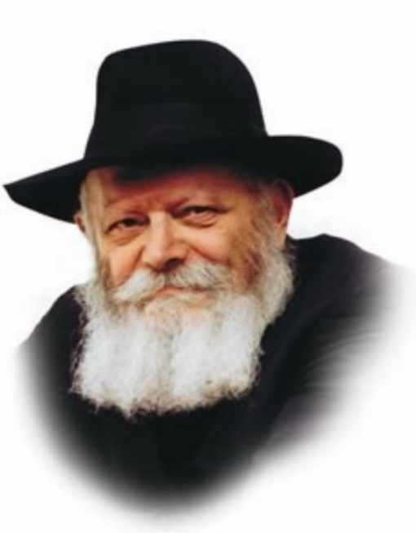

The name of a Torah portion alludes to the common thread that runs through the entire narrative. Thus, although this week's Torah portion, Emor, contains many different ideas, the name itself is significant and expresses the central theme of all of them.

The literal meaning of the Hebrew word "emor" is "say." It implies an ongoing action, a perpetual commandment that applies in all places and in all times.

Emor teaches us that thought is not enough; a person must carry the thought process one step further and express what he is thinking in speech as well. Speaking requires the person to weigh and assess his thoughts, working them over in his mind until he comes to a satisfactory conclusion.

Yet why is merely thinking insufficient? Because as human beings, we cannot know what is going on in someone else's mind; if our thoughts are not expressed verbally, no one else can derive any benefit from them. Thus the Torah commands us to "say" -- to reveal our good thoughts and ideas, and to share them with our fellow man.

In accordance with the commandment "And you shall love your fellow as yourself," a Jew is obligated to share whatever good he possesses with others. Good thoughts, thoughts that have meaning and significance, are in this category, for expressing them can bring enjoyment, enlightenment and encouragement to our fellow Jew.

The way in which our thoughts are expressed is also important. The Jew is required to convey them in an effective and pleasant manner so they will have the desired effect on the listener.

Significantly, the name of the Torah portion is Emor (say), and not Daber (speak). Daber is a harsher term, implying the use of strong language to convey a point. Emor, by contrast, implies a softer kind of speech, and a more pleasant way of communicating.

The commandment to reveal our thoughts to our fellow man and exert a positive influence on others must be carried out in a tender and loving manner. Threats and intimidation have no place in the Jew's vocabulary. Every Jew without exception is worthy of being addressed with affection and respect, regardless of their spiritual standing or actions.

This then is the lesson of this week's Torah reading: Having good thoughts is not enough. In order to have a positive influence on others we must reveal them verbally, and in the most pleasant manner possible.

*Reprinted from the Parshat Emor 5757/1997 edition of L’Chaim Weekly, a publication of the Lubavitch Youth Organization in Brooklyn, NY. Adapted for Maayan Chai from Hitva'aduyot 5742*

**Thoughts that Count for Parshat Emor**

*And you shall count for yourselves the day after Yom Tov* (Lev. 23:15)

In counting sefira, the days between Pesach and Shavuot, we learn about the importance of time. Counting the days before Shavuot, the day on which we received the Torah, is a preparation for receiving the Torah, which emphasizes the value of time. Every Jew is obligated to occupy as much time as possible in Torah study, and not waste time that could be used for this purpose. *(Likutei Sichot)*

*Until the morrow of the seventh week you shall count fifty days...You shall make a proclamation on this very day; a holy convocation shall there be unto you* (Lev. 23:16,21)

Shavuot commemorates the season of the giving of the Torah, but there is no mention of a specific date when the Torah was given. G-d did this so that one should not limit Torah to a certain time. Every day a Jew should view himself as having just received the Torah on that very day. *(Kol Toda) Reprinted from L’Chaim Weekly.*

**Rabbi Berel Wein on**

**Parshat Emor 5782**

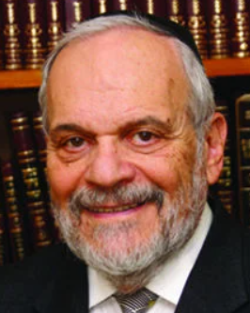

One of the central themes in this week's Torah reading concerns the special and unique laws and commandments that pertain to the kohanim – the family of Aaron who became the priests of Israel. While the people of Israel did not democratically elect them to serve in that exalted role, they were, rather, appointed to their duties and status by the will of Heaven, as expressed through Moshe.

We have seen earlier in the Torah that there was hesitancy on the part of Aaron to accept his role of priesthood. Nevertheless, at the insistence of Moshe and the direction of Heaven, the family of Aaron became the everlasting chain of priesthood that exists within Jewish society even until today.

It is obvious that the Torah was aware of the pitfalls of choosing the priesthood instead of electing it through the medium of the will of the people of Israel. Later in the Torah, a rebellion was mounted against this notion and Moshe's leadership, and one of the main complaints against them would be that somehow Moshe was guilty of nepotism in choosing his brother Aaron as the first and founding member of the priesthood of Israel. Yet, the Torah did not flinch from establishing Aaron and his family as the priesthood of Israel, and that choice has weathered all storms, and remains valid and vital, even in current Jewish society, thousands of years after Moshe and Aaron are no longer with us.

Truly, human beings have many thoughts, plans, and ideas, but eventually it is the will of the L-rd that will prevail and survive. All human choices are, by their very nature, subject to fallibility and mistakes. But the will of Heaven always has the imprint of perfection and infinity upon it.

Aaron and his descendants have a special place in Jewish life. They are entitled to financial support, social favor, and status. The laws that we read in this week's portion still apply to them. In my experience, I have noticed that kohanim possess a special pride in their heritage and in their uniqueness. Judaism, which always is a meritocracy, nevertheless, creates an aristocracy to the priesthood of Aaron and his descendants.

Scholarship, piety and even leadership are fields that are open to each and every Jewish person, without regard to ancestral advantage. However, the service of bridging the gap between G-d and the Jewish people, between the practical and mundane parts of life, and that of the Temple service with the exalted infinity that the temple was meant to encompass, was a task that was left those that were chosen by Heaven for the fulfillment of that very role – Aaron and his family.

  Not every kohen was necessarily fit for the task, nor did he live up to the responsibilities of the priesthood. However, as a group and as a class, it is obvious that even until today, the family of Aaron is deservedly held in high regard throughout Jewish society, and remains a constant reminder of the will of Heaven as expressed in our own societal lives.

*Reprinted from the current website of rabbiwein.com*

**The Significance of “Them”**

*The festivals of G-d, which you proclaim them to be holy convocations, these are My festivals* (Lev 23:2)

The word "them" appears to be superfluous. During the holidays we are obligated to rejoice, but we should also be sure to invite the needy to the festive meals. "Them" refers to the underprivileged who need to be invited. (Noam Magdim) *Reprinted from the Archives of L’Chaim Weekly.*

**Parshas Emor:**

**The Love of Chessed**

**By Rabbi Bentzion Shafier**

**Founder of TheSmuz.com**

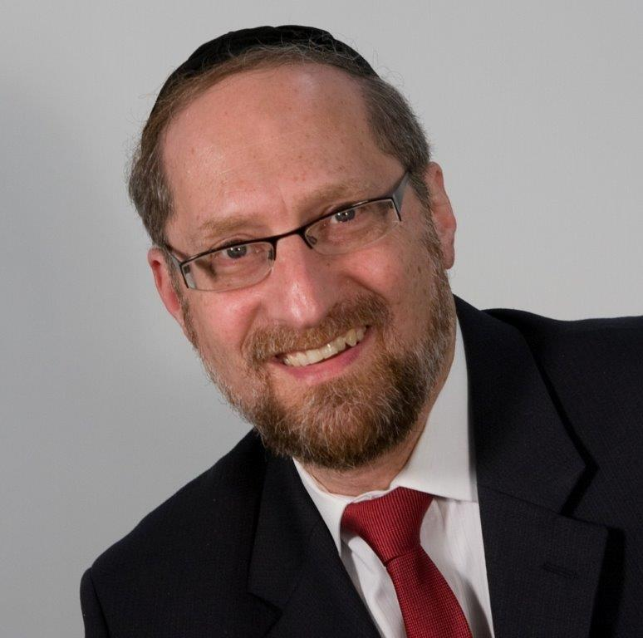

“*A cow or a sheep, it and its child, do not slaughter on one day*.” Vayikrah 22:28

In one of the many mitzvahs that teaches us how to deal with animals, the Torah commands us not to kill a mother and its offspring on one day.

The Sefer HaChinuch explains that one of the rationales behind the mitzvah is “to train ourselves in the trait of mercy, and to distance ourselves from the trait of cruelty. Even though we are permitted to slaughter animals to eat, we must do so in a merciful manner. Killing both the mother and the child in the same day is merciless and will train us in brutality. Therefore, the Torah forbids it.”

This Sefer Ha’Chinuch is difficult to understand. If the Torah is concerned about the good of the animal and its suffering, then the logical thing to do would be to forbid slaughtering it. If, on the other hand, the Torah is concerned about man and the damage such actions will have on him, then slaughtering another living creature to consume its flesh is about as barbaric an act as one could imagine.

Surely the act of killing the animal should be forbidden altogether. Yet the Torah allows you to kill animals for any productive reason: whether for their hides, their meat, or any other use. Not only that, you may slaughter as many of them as you like. You may butcher a thousand cows in one day to make shoes to bring to the market – this won’t lead you to cruelty – but make sure that none of these animals are related. If two of those cows are mother and child, it is barbaric. Don’t do it! This mitzvah seems very difficult to understand.

The answer to this question is based on understanding how our middos are shaped.

In many places the Sefer HaChinuch stresses that a person’s actions molds his very personality. If he acts with kindness and compassion, these traits become part of his inner nature. He will then feel other people’s pain, and it will become difficult for him to ignore their pleas for help. He will become a kind, compassionate person. The opposite is true as well.

If a person acts with cruelty, this trait will become part of him. It will be more difficult for him to care about another person’s plight. He will have a difficult time being sensitive to the suffering of others. He will have adopted callousness into his inner essence.

**Dovid Ha’Melech Was a Mighty Warrior**

According to this logic, it would follow that Dovid Ha’Melech should have been one of the cruelest men in history. He was known as a mighty, merciless warrior. He killed a mountain lion with his bare hands. He won the rights to marry Shaul’s daughter by killing and disfiguring 200 Philistim and bringing back their body parts to the king. When Avshalom waged war against him, Chushi advised, “Do not think of ambushing him (Dovid) at night, for everyone knows that he fights like a bear.” And Dovid said about himself, “I will seek out my enemy and have no mercy upon them.”

Yet we know that Dovid was one of the kindest, most compassionate men who ever lived. Tehillim is not the expression of a cruel man. It is a manifestation of his pure devotion to HASHEM, the outpourings of a heart that is pure, kindly and full of compassion. How is it possible that going to war didn’t ruin him?

**The Formula for Perfecting One’s Middos**

The Orchas Tzadikim in his introduction explains that perfecting one’s middos is comparable to a chef preparing a meal. The right ingredients, in the right proportions, prepared in the right manner, will yield a delicious dish. However, all three have to be correct. If, for example, instead of sautéing the onions for 10 minutes, you leave them on the flame for an hour, or if instead of a teaspoon of salt you add a cup, the food will be inedible. It is the quality of the ingredients, in the proper amounts, prepared correctly, that determines the final product.

So too, he explains, when working on one’s character traits. It is the right amount of the right middah in the right time that is the key to perfection. Each middah has its place, time, and correct measure.

This seems to be the answer to Dovid Ha’Melech. When he went to war, it was in the manner that HASHEM directed him. HASHEM designed the human and understands the delicate balance within him: what affects him and how. HASHEM commanded us to make use of certain behaviors, in certain measures, and at certain times.

The same act when done for the wrong reason will be disastrous to the person. However, when it’s done for the right reasons, in the right measure, it will not harm him. Dovid remained pure and unsullied because he followed the Torah’s system of self-perfection, designed by the only One who truly understands the nature of the human.

**The Torah: the Ultimate System of Perfection**

This seems to be the answer to the Sefer Ha’Chinuch as well. The Torah isn’t concerned about the pain of the animal; it is concerned about man. Man is the reason for creation. Everything in existence was formed to serve him. However, man was fashioned in a delicate balance. If he uses this world for its intended purpose, in the right way, in the right time, then he grows and perfects himself. However, if he uses the world incorrectly, in the wrong manner, or to the wrong extent, he is damaged by that process.

The act of killing a mother and child is akin to wiping out generations; it is pitiless and cruel. HASHEM, Who understands the balance and nature of man, has told us that killing an animal for good use will not lead you to a hardened nature, provided you do so within the given boundaries. Remain within the system and you are safe. Leave these guidelines and you are in grave danger.

This concept is very applicable as it helps us appreciate the wisdom of the Torah’s system for growth. There is much that modern man understands about the inner workings of the human, and there is at least as much, if not more, that he doesn’t understand. HASHEM has designed us and has given us the guidebook for perfection. It is our job to follow the Torah’s directives in the right balance, in the right time, in the right manner, thereby actualizing our potential as the reason for all of creation.

*Reprinted from the current website of TheShmuz.com*

**Three Victims of Ax Attack in Elad, Israel Leave Behind 16 Orphans**

**By**[**Yaakov Ort**](https://www.chabad.org/search/keyword_cdo/kid/12009/jewish/Ort-Yaakov.htm)



**From left to right: Boaz Gol, 49, Yonatan Havakuk, 44 and Oren Ben Yiftach 35 who were murdered by axe wielding terrorists in Elad, Israel Between the three martyrs, they leave behind 16 orphans**

JERUSALEM— The three victims of a terror attack in the predominantly religious Israeli city of Elad on Thursday were named early Friday as Yonatan Havakuk, 44, Boaz Gol, 49, and Oren Ben Yiftah, 35, all fathers who together leave behind 16 orphans. Two other Jews were also critically wounded.

Gol, a resident of Elad who earned his living as a mechanic, was returning home from a Torah class in a local synagogue when he was brutally murdered. He is survived by his wife and five children.

Prior to the attack, Ben Yiftach, a resident of Lod, had driven a leading local rabbi, Rabbi Yaakov Landau, to deliver a [Torah](https://www.chabad.org/library/article_cdo/aid/1426382/jewish/Torah.htm) class in Beit Shemesh. During the trip, he spoke to the rabbi about matters of faith and his own spiritual work. After the trip, he continued to Elad, where he was murdered. He leaves behind a wife and six children.

Havakuk, a resident of Lod, was murdered after he rushed to look for one of his sons in the park after hearing about the attack. He leaves behind a wife and five children.

Israeli security forces have arrested two suspects. Footage from the scene of the attack shows the terrorists running down the street armed with axes.

Reprinted from the May 6, 2022 website of Chabad.Org

**Reprint of Rabbi Akiva**

**Aaronson’s Outline of Judaism**

**By Daniel Keren**

(“The Foundation of Judaism by Akiva Aaronson,” 216 pages, paperback, distributed by Feldheim, 2021)

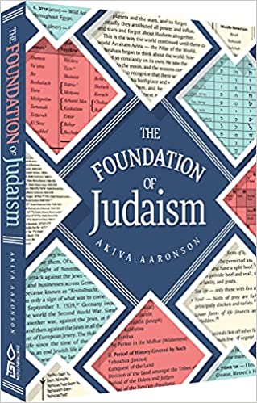

Rabbi Akiva Aaronson’s easy-to-read and informative book about the essential foundations of Judaism was first published in 1997 by Targum Press. Almost 25 years later, “The Foundation of Judaism” has been republished in an updated format.

Not only is this a good gift for a Bar or Bat Mitzvah boy/girl (along with perhaps a modest check), but it can also be a life-changing and spiritual life-saving gift to give to a relative, neighbor or workplace colleague who has not been blessed with a yeshiva, Bais Yaakov or Jewish day school education.

And even for those of us who have had a good Jewish education, Rabbi Aaronson’s “The Foundation of Judaism” offers an important refresher course in understanding and focusing on the important principles of Yiddishkeit (Yahudut.)

The paperback book is full of charts that explain important historical, religious and cultural aspects of Judaism. Not only is it a valuable resource for a Jew from a secular background but a great resource also for schools to utilize for their student bodies.

Rabbi Aaronson’s book inspired by his years of teaching to students at Yeshivas Marbeh Torah in Bnei Brak and Yeshivas Darche Noam/David Shapell College of Jewish Studies in Yerushalayim consists of seven basic chapters. Chapter 1 and Chapter 2 focus on Basic Principles of Judaism and Basic Jewish History. Other subsequent chapters highlight on the Introduction to Lashon HaKodesh; the Foundation of Tefillah; Introduction to the Torah; the importance of the Transmission of the Torah and last but not least a chapter on the significance of Halachah. “The Foundation of Judaism” concludes with informative biographies of important Jewish scholars, a Bibliography of important recent Jewish books and a glossary of important terms and Jews that all Jews should understand.

Readers may recall a modern-day classic also written by Rabbi Akiva Aaronson – “People of the Book: 500 Years of the Hebrew Book” that was published a few years ago by Feldheim that highlights the important transformation to the development of Torah study by the invention of the printing press.

Rabbi Aaronson’s new book on “The Foundation of Judaism” can be found at Jewish bookstores or can be purchased by contacting the distributor – (800) 237-7149 or [sales@feldheim.com](mailto:sales@feldheim.com)

**The Literary and Audio Legacy of**

**Rabbi Zechariah Wallerstein, Zt”l**



The New York Metropolitan Jewish community is still reeling in shock at the news of the recent petirah of Rabbi Zechariah Wallerstein, zt”l, who while only 64 years old had become one of the most legendary Torah educators in America, literally touching the lives of thousands of young boys and later young ladies, saving countless neshamos (souls) for Klal Yisroel.

While amazing stories of Rabbi Wallerstein’s mesiras nefesh on behalf of his fellow Jews continue to come out after his death and will no doubt be published in an inspiring biography, we can still gain chizuk (inspiration) from his thousands of hours of taped Torah lectures to different groups across the spectrum of the Jewish world – Chassidic, Yeshivish, Modern Orthodox, etc.

Thanks to the longtime partnership of Rabbi Wallerstein and the website Torahanytime.com, one can listen to almost 800 video tapes of one of the most insightful voices of the American Jewish scene. Just google Rabbi Zecharia Wallerstein – Torahanytime.com and all of those video tapes will pop up. Among the more recent postings that you might want to view or listen to, you can google – Levaya of Rabbi Zecharia Wallerstein (57 minutes) or the Rabbi’s 5-minute explanation of “Beyond a Reasonable Doubt that G-d Exists.”

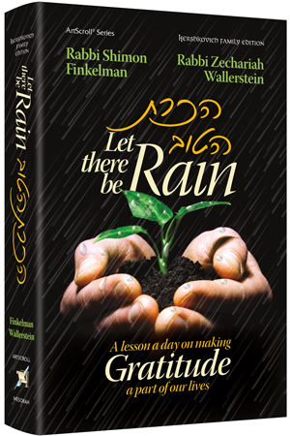 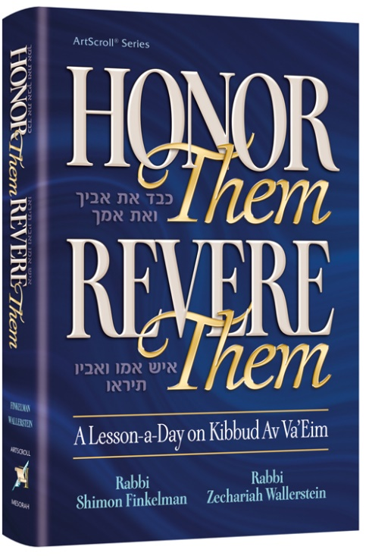

Before his untimely passing away earlier this month on Rosh Chodesh Iyar, in conjunction with Rabbi Shimon Finkelman, Rabbi Wallerstein had two important books published by ArtScroll Publications – “Honor Them, Revere Them: A Lesson a Day on Kibbud Av Va’Eim” [Honoring Your Parents] and “Let There Be Rain: A Lesson a Day on Making Gratitude a Part of Our Lives.”

May Hashem comfort his wife, children and grandchildren and may Rabbi Wallerstein continue to be a meilitz Yashar in shomayim for all his students and all of Klal Yisroel in America and around the world.

*Reprinted from this week’s edition of the Jewish Connection.*